Experiment 1:
Ohm's Law and discharging of a capacitor

Objective: In this experiment, the resistance of a resistor will be calculated.

Background:

Capacitors store electrical charge according to the equation
(1)
where C is capacitance, Q is charge, and V is voltage.

When a capacitor is discharged, is is possible to prove that the voltage will decrease as a function of time according to the equation
(2)
Where V(t) is the voltage at any given time, V₀ is the initial voltage, t is time, R is resistance, and C is capacitance.

Materials you will need:
A Multimeter (or SPARK with Current and Voltage sensor)
One Capacitor
Alligator-Clip Wires
Power Supply
One RGB LED-Strip

Warnings:
Have your instructor check your connections before applying power to the circuit.

Procedure:
Connect the circuit in the following configuration:
*Notes: – The resistor is integrated into the LED Strip. The LED Strip has several possible neagative connectors. Choose black and the color you like most. Make sure positive and negative connections to the LED and the capacitor are correct.
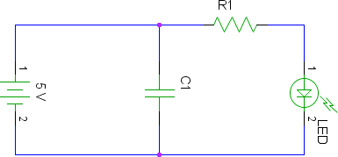

Have your instructor check your connections before plugging in the power supply.
Connect a multimeter or SPARK to monitor the Voltage of the capacitor.
Disconnect the power supply, and monitor the time it takes for the voltage to reach 3.0 V.
Calculate the Resistance of the resistor using linearization of data techniques.

